**competition:**

apps are not simple and fast enough especially on phones

* fitness apps have way more users than sports related apps
* infinitehoops web & iphone app - 30,000 users <http://www.infinitehoops.com>
* infinitefootball web & iphone app <http://www.infinitefootball.com>
* timpik facebook app - 5,700 users <https://www.facebook.com/Timpik>
* sportilia facebook app - 1,500 users <https://www.facebook.com/Sportilia>
* no app on google+
* study facebook, google+, apple app store categories to notice trend in what people are using by user and download count

**ongoing tasks:**

* checkout infinitehoops.com and other competition

**tasks:**

* display newly created game
* display games within radius
* login/register
* crud table in aws

**backlog:**

* features
  + view upcoming games based on location automatically if location allowed
  + view past games
  + view current games
  + search games by location, sport, age, gender
  + sort results
  + elect for alerts to sports within radius
  + alert when games created within radius
  + alert when ready to play
  + respond to alert
  + alert sent to email, app and text
  + search and find someone via email or phone number
  + create group with location, time, recurring, members
  + no activity on group will send notification that group will be closed
  + weather status
  + view contacts
  + view groups
  + view groups create
  + view parks visited on map
  + user profile
  + tell a story of why they need app
  + disclaimer that not responsible for anything
  + preload games known to be played at parks to encourage folks to go there and interact with games
  + show videos of games at rucker park to grow excitement
  + neighbourhoods guides (championships, rivalry)
* map functionality
  + look at all google map examples <https://developers.google.com/maps/documentation/javascript/examples/>, also look at bing and other folks for inspiration in their examples
  + weather
  + radius search
  + travel mode
  + panoramic
  + load video of game played
  + heat map
  + ads
  + visualization of games user has played and where travelled to keep as sport diary
  + <http://www.morethanamap.com/demos/visualization/flights>
* ui
  + 99designs.com competition
  + Thor design
  + cartoon logo of pickup truck with bunch of sports balls and hot chicks in bikini driving to game
  + analyze top sites mobile, tablet and web ui like airbnb, uber, twitter, facebook, google+ etc.
  + display picture of park, gym field
  + borrow from [www.booststrapzero.com](http://www.booststrapzero.com) themes
  + build like pinterest where games can keep going
  + examples:
    - login [www.twitter.com](http://www.twitter.com)
    - 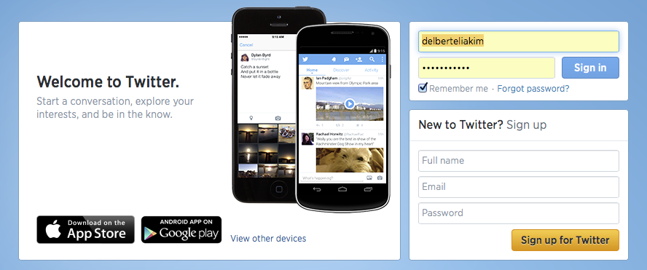
    - login [www.airbnb.com](http://www.airbnb.com)
    - 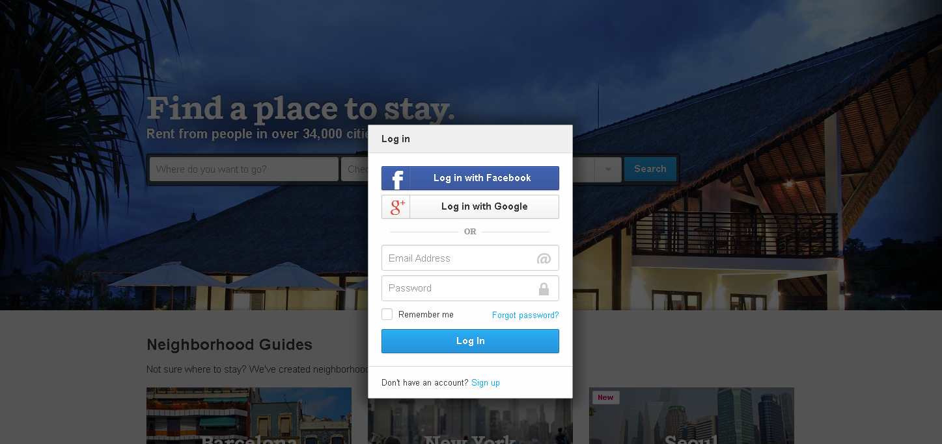
    - screen flow [www.airbnb.com](http://www.airbnb.com)
    - 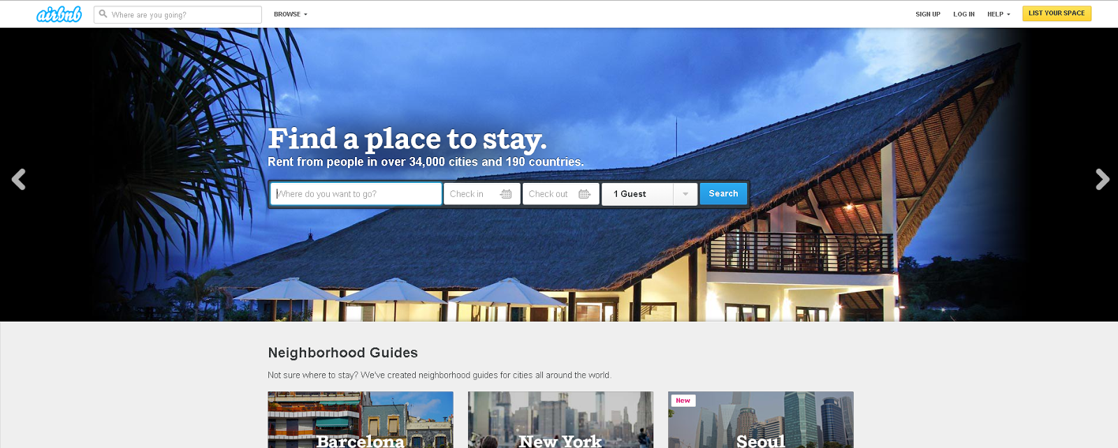
    - 
    - 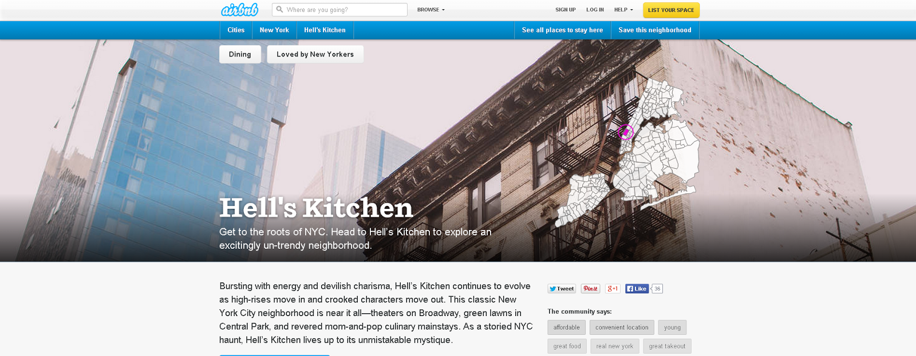
    - 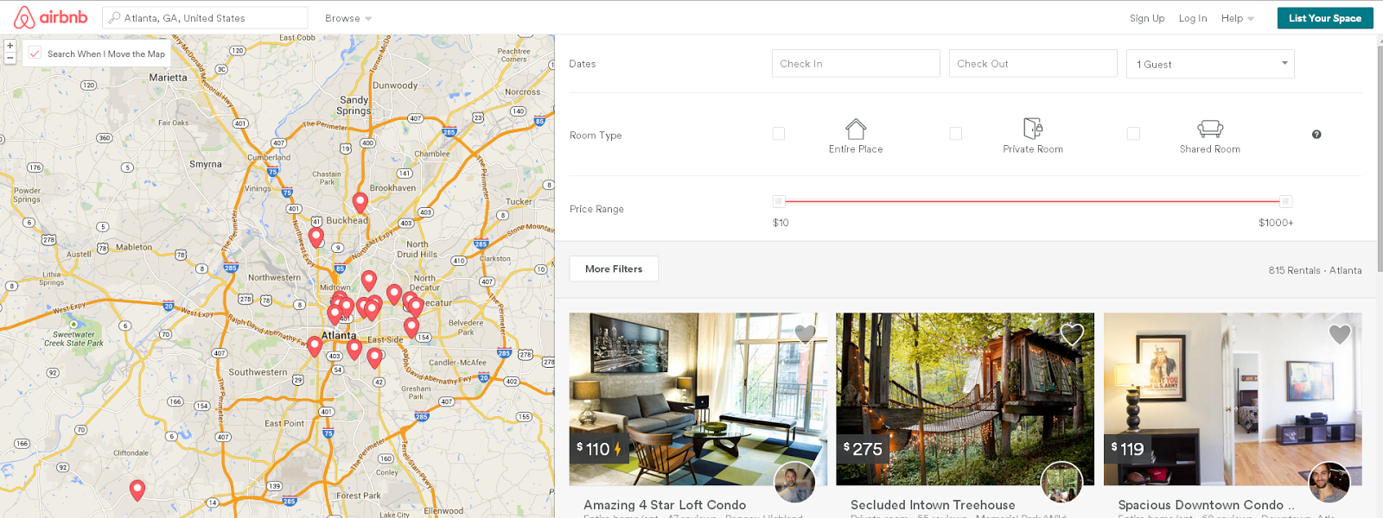
* social media integration
  + chat
  + each game should be able to be retweeted, liked, +1, instagrammed etc.
  + bind each game to social network discussion
  + build app for facebook
    - need way to preview without being a facebook user
* user feedback option
  + suggest features and let users vote
  + let users indicate if app slow and show on map around the world
* names
  + Pickup Games
  + Pickup Fitness
  + PickFit
  + Pickup Rally
  + Pickup Go
  + PicuFit
  + PicaFit
  + PickupFit
  + Pickup Fit
  + PicupFit
  + Meeaggi
  + Gamitter
* marketing
  + leagues, gyms, parks, schools, stores, web sites, espn tv ads
  + lots of organizations need practice squads that are hard to find but this app can facilitate it
  + giveaways
  + sponsor small companies that neighbor product
  + create badge so users self promote site
  + get promoted on fastcompany and other sites
  + move into health and fitness section where more users are
* testing
  + different devices and browsers
  + unit tests
  + ui/selenium tests
* security
  + //cdn.siftscience.com/s.js like airbnb.com
  + xss, csrf, cookie stealing, over posting, open redirection
  + sql injection
  + https
  + authorize all methods, classes
  + hackers hack site
  + microsoft, google, ibm, apple, amazon tools to test security holes
* deployment and staging
  + amazon aws staging
  + version control
  + version migration
  + database migration
* infrastructure
  + internationalize

**can wait til after launch:**

* add items from meetings and notes
* integrate with siri
* track stats, calories burnt, recommended eating, training, videos
* suggest healthy lifestyles everyday
* earn points for contributing to community like waze
* split app into parts for each sport like runtastic
* build app for google+
* iphone app using swift
* android app
* xamarin app?
* provide api for others to use functionality
* prepare it for iwatch which a lot of fitness folks will use
* prepare for google glass
* prepare for any form factor / wearable